Exploratory Data Analytics Report

**Summary Statistics**

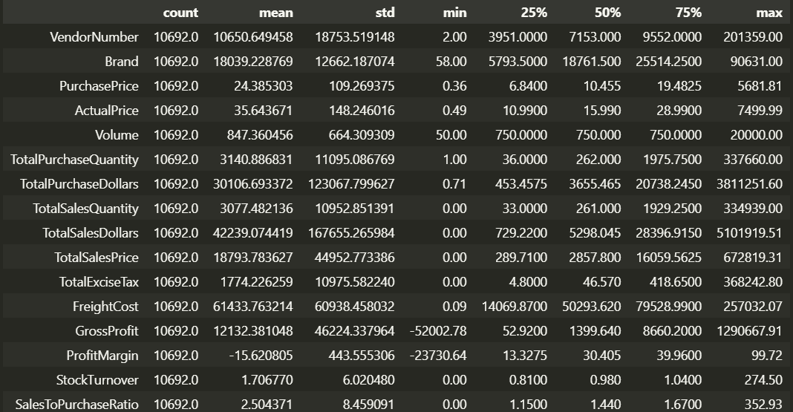

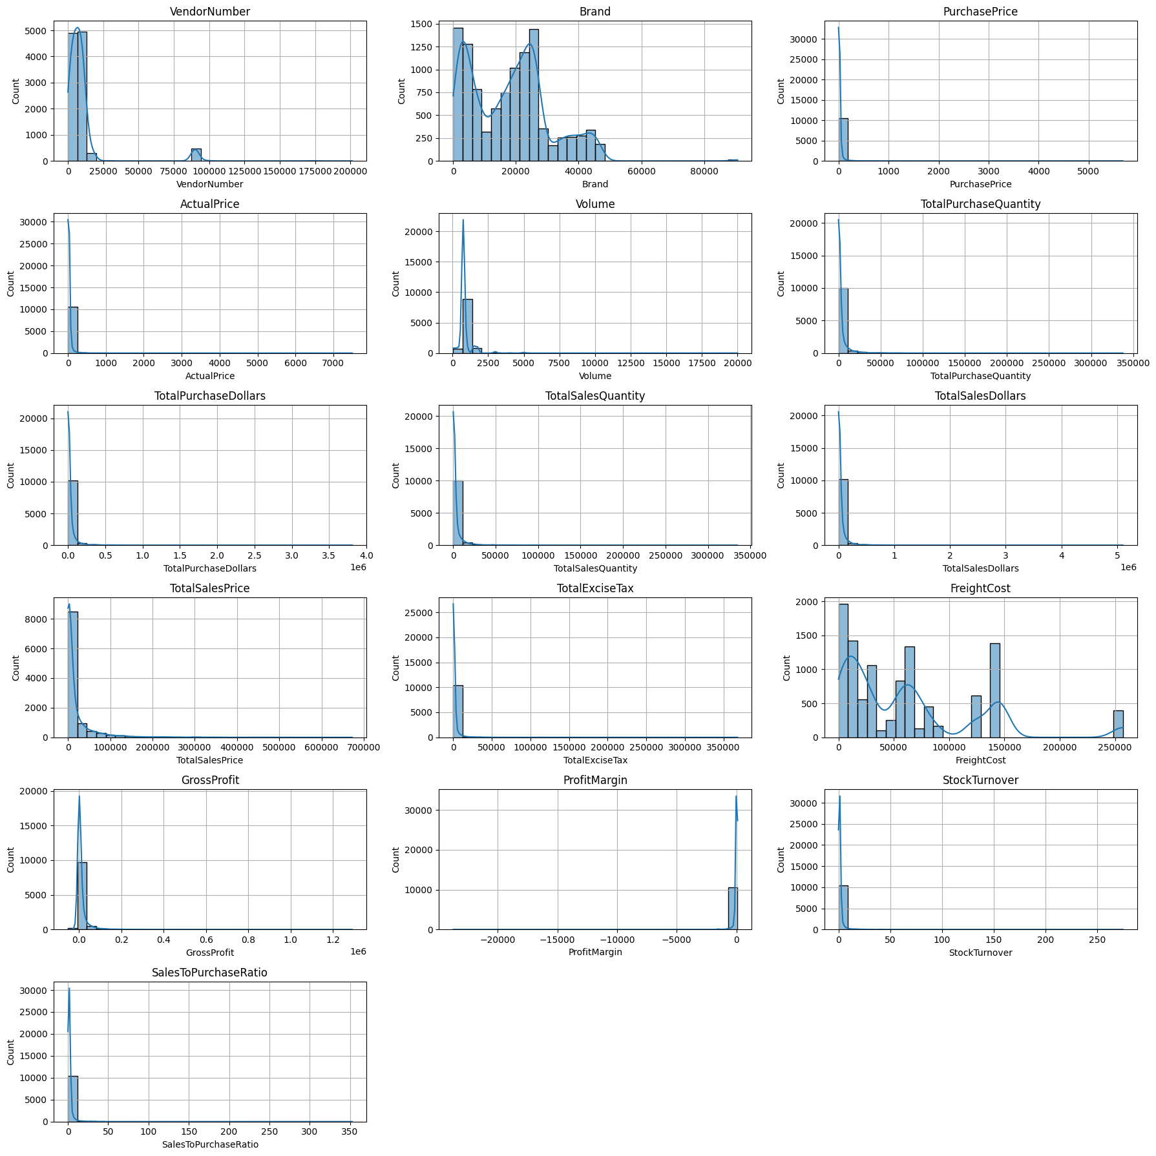

Negative & Zero Values:

Gross Profit: Minimum of -52,002.78, indicating potential losses due to high costs or heavy discounts. This could be due to selling products at lower prices than their purchase costs.

Profit Margin: Has a minimum of -o, which suggests instances where revenue is zero or even lower than the total cost, leading to extreme negative profit margins.

Total Sales Quantity & Sales Dollars: Some products show zero sales, indicating they were purchased but never sold. These may be slow-moving or obsolete stock, leading to inventory inefficiencies.  
  
Outliers Detected by High Standard Deviations:  
Purchase & Actual Prices: The maximum values (5,681.81 & 7,499.99) are significantly higher than the mean (24.39 & 35.64), indicating premium product offerings.

Freight Cost: Extreme variation from 0.09 to 257,032.07 suggests logistics inefficiencies, bulk shipments, or erratic shipping costs across different products.

Stock Turnover: Ranges from 0 to 274.5, suggesting some products sell rapidly while others remain unsold for long periods. A value greater than 1 indicates that sales for a product exceed the purchased quantity due to older stock fulfilling orders.

**Data Filtering**

To enhance the reliability of the insights, we removed inconsistent data points where:

· Gross Profit ≤ 0 (to exclude transactions leading to losses).

· Profit Margin ≤ 0 (to ensure analysis focuses on profitable transactions).

· Total Sales Quantity = 0 (to eliminate inventory that was never sold).

**Correlation Insights**

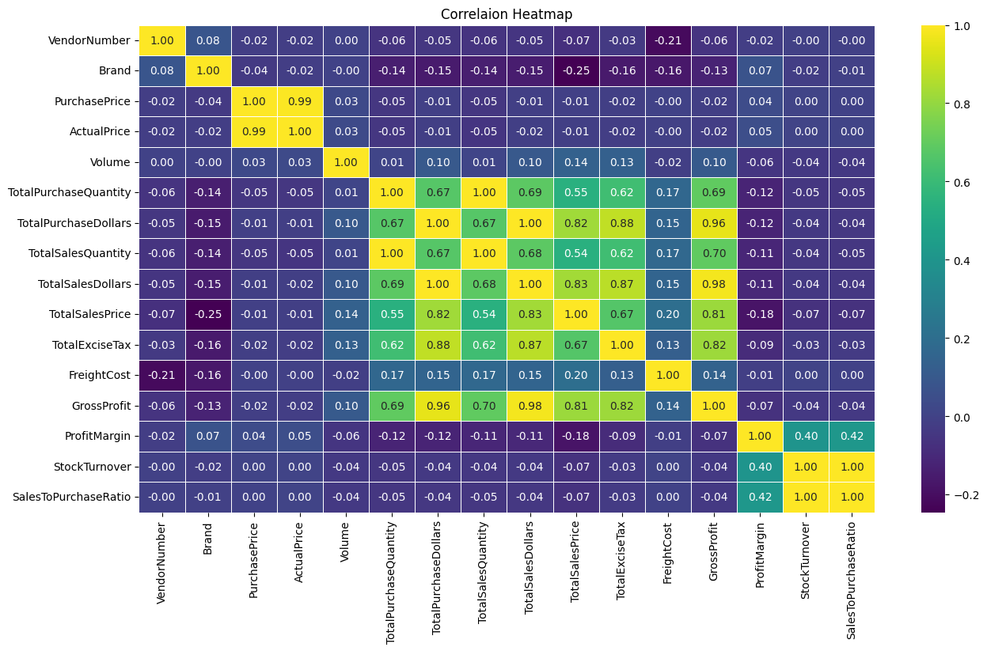

Purchase Price vs. Total Sales Dollars & Gross Profit: Weak correlation (-0.012 and -0.016), indicating that price variations do not significantly impact sales revenue or profit.

Total Purchase Quantity vs. Total Sales Quantity: Strong correlation (0.999), confirming efficient inventory turnover.

Profit Margin vs. Total Sales Price: Negative correlation (-0.179), suggesting increasing sales prices may lead to reduced margins, possibly due to competitive pricing pressures.

Stock Turnover vs. Gross Profit & Profit Margin: Weak negative correlation (-0.038 & -0.055), indicating that faster stock turnover does not necessarily equate to higher profitability.

**Some Points**

1. **Brands for Promotional or Pricing Adjustments**

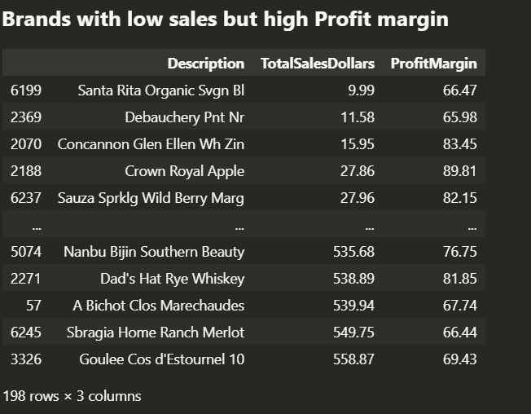

198 brands exhibit lower sales but higher profit margins, which could benefit from targeted marketing, promotions, or price optimizations to increase volume without compromising profitability.

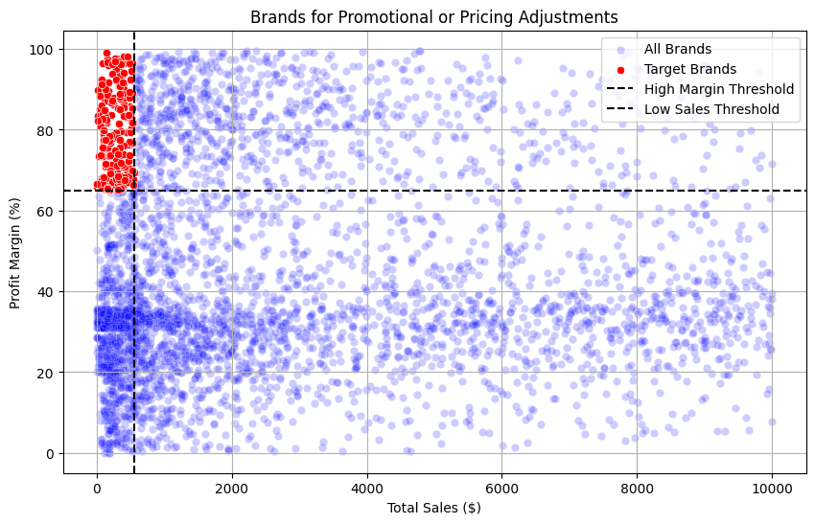

1. **Top Vendors by Sales & Purchase Contribution**

The top 10 vendors contribute 65.69% of total purchases, while the

remaining vendors contribute only 34.31%. This over-reliance on a few

vendors may introduce risks such as supply chain disruptions, indicating a

need for diversification.

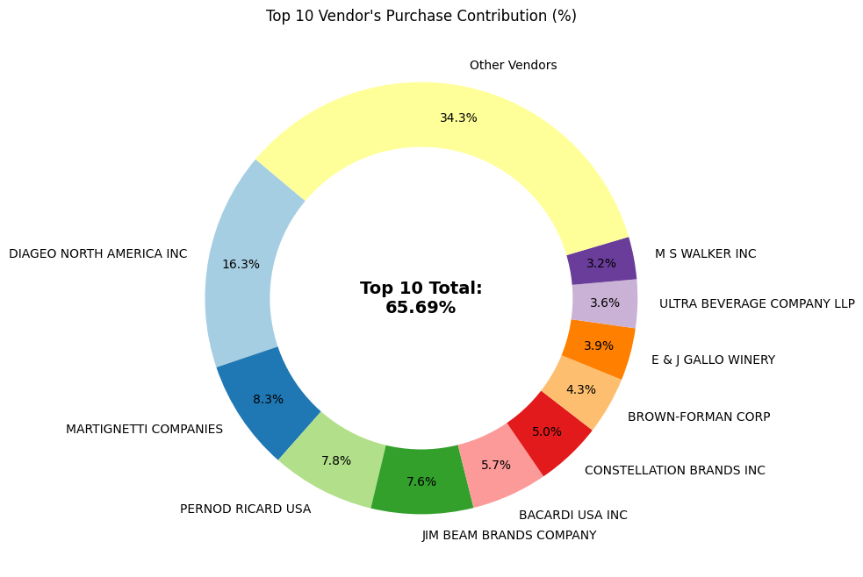

**3.** **Impact of Bulk Purchasing on Cost Savings**

Vendors buying in large quantities receive a 72% lower unit cost ($10.78 per unit vs. higher unit costs in smaller orders).

Bulk pricing strategies encourage larger orders, increasing total sales while maintaining profitability.

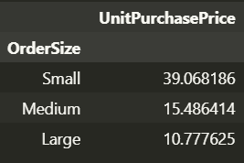

**4. Identifying Vendors with Low Inventory Turnover**

Total Unsold Inventory Capital: $2.71M

Slow-moving inventory increases storage costs, reduces cash flow efficiency, and affects overall profitability.

Identifying vendors with low inventory turnover enables better stock management, minimizing financial strain.

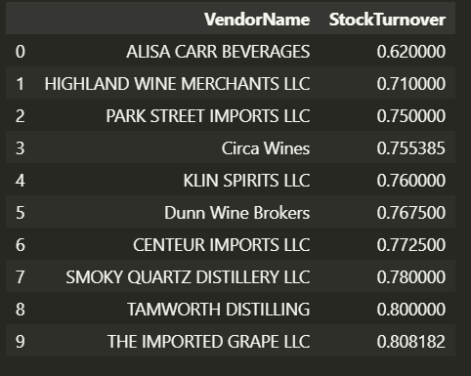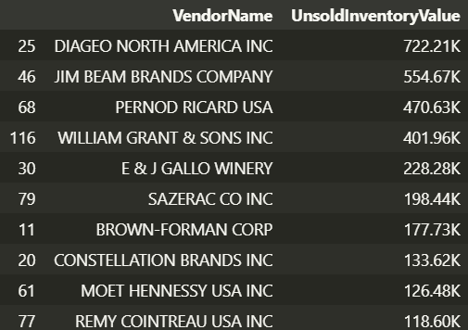

**5. Profit Margin Comparison: High vs. Low-Performing Vendors**

Top Vendors' Profit Margin (95% CI): (30.74%, 31.61%), Mean: 31.17%

Low Vendors' Profit Margin (95% CI): (40.48%, 42.62%), Mean: 41.55%

Low-performing vendors maintain higher margins but struggle with sales

volumes, indicating potential pricing inefficiencies or market reach issues.

Actionable Insights:

* Top-performing vendors: Optimize profitability by adjusting pricing, reducing operational costs, or offering bundled promotions.
* Low Performing Vendors: Improve marketing efforts, optimize pricing strategies, and enhance distribution networks.

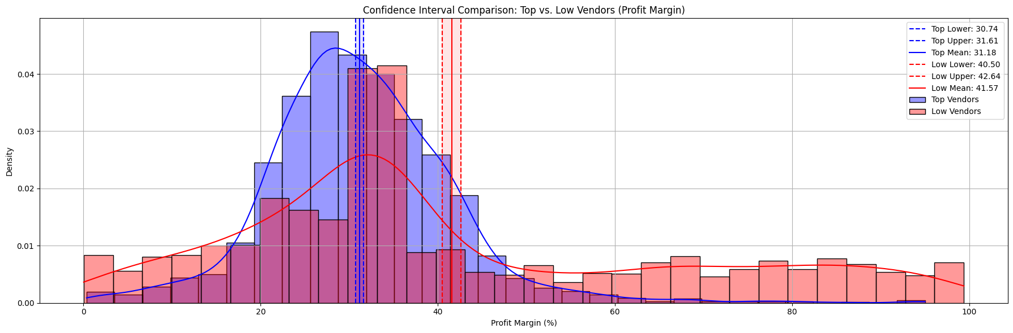

Final Recommendations

· Re-evaluate pricing for low-sales, high-margin brands to boost sales volume without sacrificing profitability.

· Diversify vendor partnerships to reduce dependency on a few suppliers and mitigate supply chain risks.

· Leverage bulk purchasing advantages to maintain competitive pricing while optimizing inventory management.

· Optimize slow-moving inventory by adjusting purchase quantities, launching clearance sales, or revising storage strategies.

· Enhance marketing and distribution strategies for low-performing vendors to drive higher sales volumes without compromising profit margins.

· By implementing these recommendations, the company can achieve sustainable profitability, mitigate risks, and enhance overall operational efficiency.